Slide 1

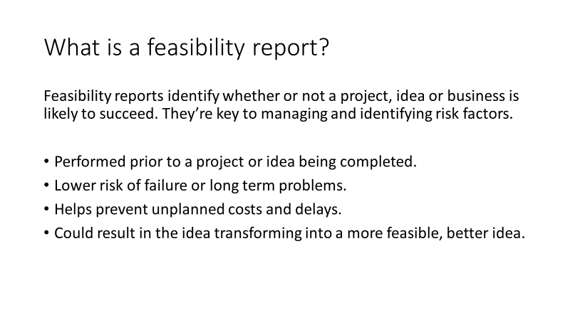

(Ask Media Group, LLC, n.d.)

Feasibility reports are a key part of project management that help reduce risk of projects, especially larger projects, and help with planning and resource distribution. They take place before a project is completed, usually before it’s even started, as the risk management and planning help with project stability and completion. As well as this, feasibility reports help lower risk of failure and issues like delays and costs, which can impact a project of any scale. It’s also worth mentioning that feasibility reports can help transform a project idea into a more secure proposal that is more successful.

Slide 2

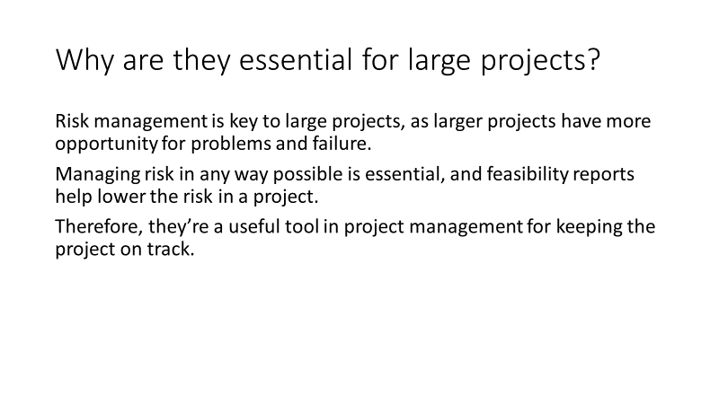

Feasibility reports are key in any project, however larger projects require better planning and risk management. The more steps taken towards managing risk, the higher chance there is of project success. This means that feasibility reports are essential for large projects, as not considering the feasibility of a project at a larger scale could be catastrophic in terms of time loss and financial loss.

Slide 3

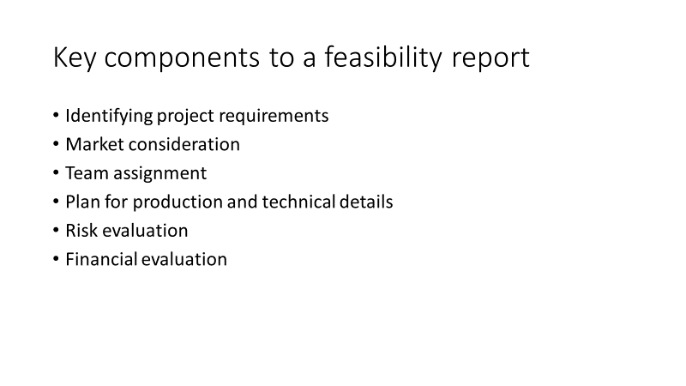

(Olufisayo, 2011) (Jetley, 2016)

Feasibility reports rely on a structure that covers multiple areas. These six areas are those that are considered key, as they each outline some key features that relate to feasibility, both in terms of a project idea, and in terms of risk, both financial and technical.

Slide 4

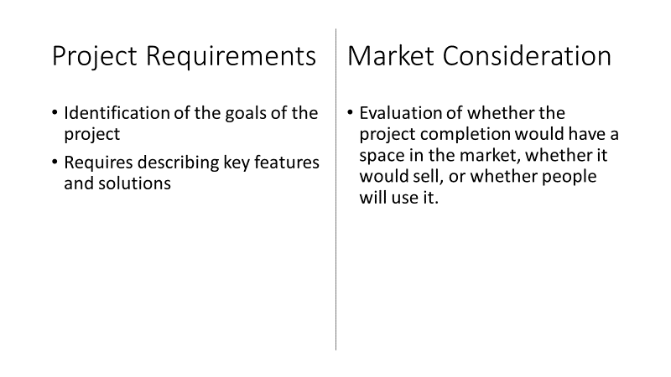

The project requirements step involves identifying the key requirements for a given project. This means identifying the core goals for the proposal of the idea, whether it fills a gap in a service, or provides functionality to another project. Effectively, this step involves justifying why the project needs to take place.

Market consideration involves making sure that said project has a space in the market, such as considering whether alternate solutions are available, and whether the project will produce a competitor to any other solutions. If there’s a gap in the market, the project would be well suited to take place, whereas if there’s no gap due to competition, it means that the project should meet some other requirements to differentiate itself from said competition; whether it means a lower price, more functionality, or a different implementation.

Slide 5

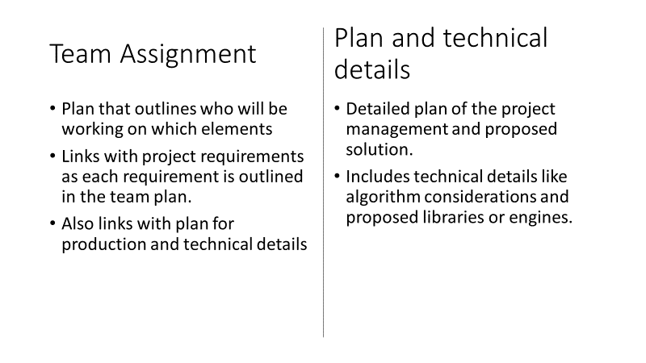

Team assignment involves assigning tasks to teams of people, as well as individuals. This links with the plan, outlined in the next step, as it allows for time management. This helps predict how long a project will take and can optimise who is used in which areas.

The plan and technical details are the key proposed method to create the project, detailing the requirements and how they’ll be met, as well as information about the technical solution, such as what library will be used and why. As well as this, it gives an opportunity for algorithms to be discussed, finding an ideal solution before the project requires the algorithm to be decided on to continue.

Slide 6

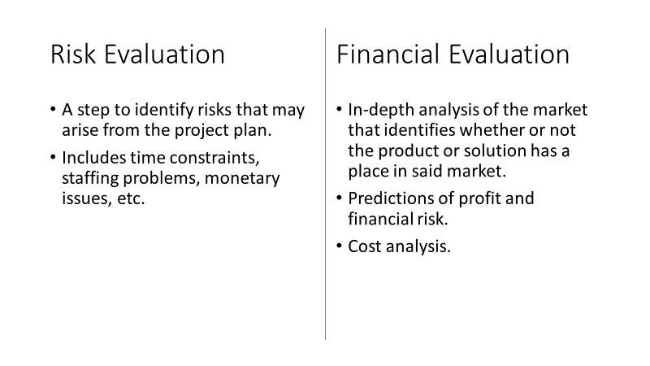

These two steps are evaluations of risk and finance, which gives time for considerations regarding risk factors like understaffing and subsequent delays, as well as cost and profit prediction. These are arguably the most important steps, as they describe the feasibility of the project itself, both in terms of finance and in terms of risk.

# Bibliography

Ask Media Group, LLC, n.d.. *What Is a Feasibility Report?.* [Online]   
Available at: https://www.reference.com/business-finance/feasibility-report-e50affa556c0fc6a  
[Accessed 21st November 2019].

Jetley, V., 2016. *What are the main components of a feasibility study?.* [Online]   
Available at: https://specialties.bayt.com/en/specialties/q/277098/what-are-the-main-components-of-a-feasibility-study/  
[Accessed 21st November 2019].

Olufisayo, 2011. *How to Prepare a Good Feasibility Report with Format.* [Online]   
Available at: https://www.entrepreneurshipsecret.com/how-to-prepare-a-good-feasibility-report-part-1/  
[Accessed 21st November 2019].